Turning 51 – September 2012

So I turned 51. And therefore obviously I can’t recall who I sent my “Turning 50” document to a year ago, so it’s posted out on the Ozone as well under Rantings. Oddly enough a year later from that episode my birthday week got even older, faster, than a year ago.

Tuesday September 4:
For Christmas my wife gave me an electric hair clipper set and she’s been cutting my hair with it every few weeks. She does a great job. Just take the clippers, snap on a large black plastic “hair length” adapter and buzz away. So Tuesday evening I’m getting a haircut sitting on a stool in the garage, holding the comb and scissors she will use when she’s done buzzing. We trade instruments when she’s done and while she’s doing the detail work around my ears and such I disassembled the clippers and clean both the length attachment and the clipper blades. I ask her if she ran the buzzer over all of my head because it went quite quickly. She says she did but asks for the clippers back to trim some spots. She takes the clippers, applies them to my head just above my right ear, and runs them up to the middle of the top of my head. No length adapter installed. Yup, right down the scalp, a racing stripe right up the right side of my head. Her first reaction is laughter, then “I can fix that!” After a look in the mirror and a few minutes of horror I decide she’s not touching my head again tonight. I will have to wear something to cover my head when leaving the house for the next 4 – 8 weeks. I have to take the photo of this colossal mishap myself as my wife won’t take the photo since she believes I only want it to send it to everyone and make fun of her by showing how badly she screwed up. I use my iPhone to capture this historic moment but I don’t plan on sharing it with anyone until the situation has passed or until I can come to grips with it. Then I go about e-mailing all my coworkers in CT to explain that I have a situation which requires that I wear a hat or bandana along with my shirt and tie for the next 4 – 8 weeks. Very awkward and embarrassing, especially when your management is deciding who to layoff in the next several weeks. Add all of this up and Bruce doesn’t sleep on Tuesday night. At all.

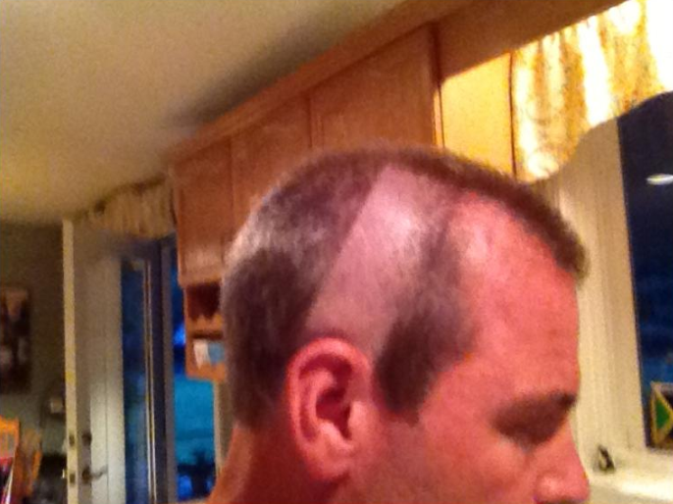

Wednesday September 5:
I select a blue silk shirt, red white and blue shirt, and my red white and blue Patriots hat for Wednesday. Turns out Wednesday is opening night for the New York Giants (against Dallas) and I get several rations of shit from people who don’t have a clue and think I’m trying to send a message to Giants fans. Also it was a very hot a humid day and I find the hat doesn’t breathe well so I’m hot and sweaty in my getup all day. So I’ve got this to deal with for another 4 – 8 weeks? Late in the day I am bumped from Thursday’s plane and have to be in CT for some critical meetings so I’ll be driving down and back tomorrow. Better get some sleep.

Wednesday night before bed I find myself peeing every 20 or 30 minutes and by the time I’m ready to go to bed it’s constant, even after peeing I still feel like my bladder isn’t empty and I need to pee (yes, you read something just like this in the note from a year ago below…). Needless to say this keeps me up for the night to ensure that I approach 2 days without sleep. In the wee hours of the morning pain begins to emerge in my right front abdomen as well as on my lower back on the right side. I attribute this to being perhaps another urinary tract infection like last year with some new twists. Or there’s something wrong with my bladder or my kidney. Lots going through my head, sleep is not one of them. I had to get up early in order to drive to CT so being awake all night ensured I wouldn’t sleep through my 4:15am alarm.

Thursday September 6:
The pain and need to pee had greatly subsided so I’m up and off driving myself to CT with a Harley bandana to cover my head. About the time I’m approaching the CT border the pain begins to return in growing fashion. I can’t get comfortable in my seated position and the pain has become a distraction from my driving. I decide that although I need to be in CT I will be in the bathroom half the time and perhaps unable to fulfill my role in the other half of the time if I’ve got this pain, so I decide to return to NH. My wife had called earlier and recommended I try to get an appointment at Dartmouth Hitchcock even if it was in the evening or the weekend at Urgent Care. I had informed her at the time that I already had an appointment in a few days at Manchester Urology to reestablish my prescription for my enlarged prostate issue which I also thought might be part of the problem anyway. I’m rethinking her advice at this point and I’ve got nothing better to do while I’m driving anyway. I give them a call when they open and amazingly they are able to get me in to see a physician’s assistant (PA) named Ana Nogueira at 9:00am so I drive directly there.

In record time I am into see Ana, she takes a urine sample (not a problem, obviously…) and orders X-rays and blood work never saying a word about the Harley bandana on my head. A dipstick test is performed on my urine sample while I’m there and determines that I do not have any infections. The results of the X-ray and blood work will take 24 – 48 hours. Ana informs me that based on my answers to all of her questions and her prodding and poking and the urine sample that my condition is nothing serious and I can go about my life with some discomfort and inconvenience. It’s only 9:45am and I’m feeling pretty good, I can be in CT by lunch time and make all my afternoon meetings. I head south to repeat my morning commute.

Shortly before 4pm the peeing sensation and pain in my back really ramps up. I’m having a hard time concentrating and cannot get comfortable in my meeting, I need to leave the room. I’m not feeling so good and decide I better head north sooner rather than later so I rejoin the meeting via teleconference and start the commute home. On the way the pain subsides. I speak with Lisa on the phone and she is running late and not yet home so I propose to pick up a pizza in Hudson on my way home. Thirty minutes later as I pull into Capri Pizza my phone rings and it’s Lisa. She has just arrived home and informs me that there are 4 messages from Dartmouth Hitchcock on our home phone, left throughout the afternoon telling me to call them. I do so and speak with the night nurse on call, Kathy. “We’ve been trying to get in touch with you all afternoon”. Yes, well you’ve been leaving messages on my home phone and no one is home. What happened to trying my cell phone or calling my Emergency Contact to help get in touch? Whatever. She tells me that my X-ray results (what happened to 24 hours?) show something which is potentially indicative of a partially obstructed colon which can be very serious.

From the X-ray results:
Findings
Supine and upright AP projections of the abdomen demonstrate dilated loops of
small bowel, particularly within the left upper quadrant, with bowel gas
extending into the colon. There is moderate amount of formed stool within the
colon. No free air is appreciated on the level of the diaphragm. There are no
abnormal calcifications along the shadows or course of the ureters. Osseous
structures are unremarkable. Lung bases are clear.
Impression
Nonspecific bowel gas pattern with prominent loops of small bowel in the left
upper quadrant. Bowel gas does extend into the colon, but a Partial small-bowel
obstruction cannot be excluded based on the radiographic appearance

“You need to go to the Emergency Room ASAP”. Seriously? I explain my frequent experiences with the ER via my wife and tell her I want to avoid that at all costs. “You need to go, we’ll send them all of your information and results from today”. Swell.

So I pick up the pizza so that I have something to eat before heading there. I get home and Lisa is working on assembling something at the kitchen counter and over her shoulder she says “I haven’t had time to make your martini but when you make it please pour me a wine as well”. I inform her that she needs to stop doing what she’s doing and listen for a minute and that probably neither one of us is going to have alcohol. Note that today has been all about my physical condition and she knows I just called the Hitchcock Clinic back. Her response to my seriousness is “You got fired”. A statement. And not about my health which has been the issue today, but about my income. Hello? After I get over my WTF moment from her response I tell her what the nurse said and that I am going to the ER. With a Harley bandana on my head.

There is another whole story about the commute to the ER as I want to go alone but against better judgement give in to Lisa’s desire to accompany me and the drive itself has a number of twists including Lisa’s need to exit the highway in a rush and run into Wendy’s for a bowel problem. But as I said that’s for another time.

Having done this before I take my laptop and a book. New and different this time is that I also cover my head with a Harley bandana. After registering at the ER I get in 90 minutes of work time on my computer catching up on all of the e-mail I couldn’t do while I was logging 500 miles on my car. I read for another 30 minutes before we get called into a room. Michael our nurse if very helpful. I am having another pain episode, the worst yet, and he sees my discomfort and decides that he is going to hook me up to an IV and get me some meds.

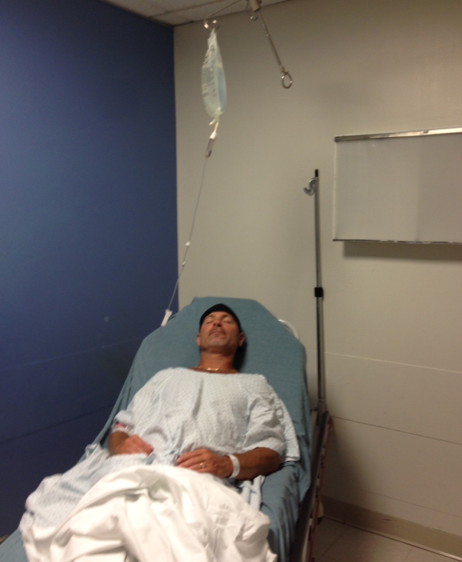

At some point the doctor comes in and asks me all manner of questions and is reviewing the information he has from the DHC. He tells me that he doesn’t believe I have any colon obstructions because I’m not sick enough. He thinks I have a kidney stone. He cancels my X-rays and orders a CAT scan. At some point I am wheeled on my gurney into a CAT scan and returned to my room. The meds are working and I’m finally beginning to doze. At some point the doctor returns and tells me that I have passed a kidney stone while in the ER. It is now in my bladder so the pain is over. There’s a little blood in my urine but that’s normal. Now I just need to strain my pee for the next day or so to find it so that I can send it in for analysis. “The good news is you passed this stone. The bad news is that most people who get a stone continue to produce stones”. Swell.

Friday September 7 – “B Day”:
So we’d logged about 4 hours at the ER and we get home around 12:30am and I get some good although short sleep as I need to get up at my usual 4:45am hour to get some work stuff moving before having to be at the Mercedes dealership for a 7:30am appointment as I was taking Lisa’s car in for tires. And wearing a Red Sox hat. I played golf Friday afternoon in a daze wearing my usual Friday Golf Jamaica hat. I did not expect to play well and played to my expectations, but got some exercise and fresh air as well. After arriving home and letting my head breathe I was treated to Lisa’s awesome homemade chicken parmesan and chocolate cake. I had 2 of everything (martinis included…) and went to be about 8:30pm and woke up 12 hours later. I can’t remember sleeping 12 hours since being an adolescent. Maybe I don’t even remember that.

Saturday September 8:
I was now 3 hours behind on Saturday morning and was hustling around with indoor chores when I threw my back out. I took some Advil and mowed the lawn and then dug up the dead grass sections in the front yard, replanted and raked – gritting my teeth all along. When I was done I could no longer stand up straight. I covered my head with a baseball cap and drove into Londonderry to run some errands including getting my pain prescription from the ER filled, hobbling hunched over all the while. I got home with 30 minutes to spare before having to drive to Epping to meet up with two project co-workers who live in the Amesbury MA area so I lay down and set an alarm on my iPhone. It was going off in what seemed like seconds. I struggle to exit the bed and make my way to the meds and toss down an 800mg Ibuprofen and a muscle relaxant and head off into stormy conditions to The Holy Grail in Epping after donning a Harley bandana. Had a good time. Medication, a Bombay Sapphire martini and a glass of Pinot Grigio helped. About 8pm I found myself a tad fuzzy and wearily made my way home. I slept pretty well Saturday night too.

Sunday September 9:
After a stormy Saturday evening I woke to a large dead branch in my back yard which required the use of my chainsaw to cut it up and cart it off to the dump. Still in some pain from the lower back tweak thing I gobbled 800mg ibuprofen and muscle relaxants for breakfast , found an appropriate baseball cap to depart the house and then worked through the cutting and loading of what turned out to be two large branches into my truck and shortly before noon unloaded it all at the dump.

Nate came over afterwards to share stories with me. Yup, this was his photo from Wednesday, and we’d texted each other on Friday with photos and comments about who could outdo who with stories from the week but we hadn’t told each other anything about the story behind the photos until Sunday afternoon. Lots of laughs, but Unbelievable that we’re both in the ER within weeks of what will be a very challenging route in the Grand Canyon for 5 days.

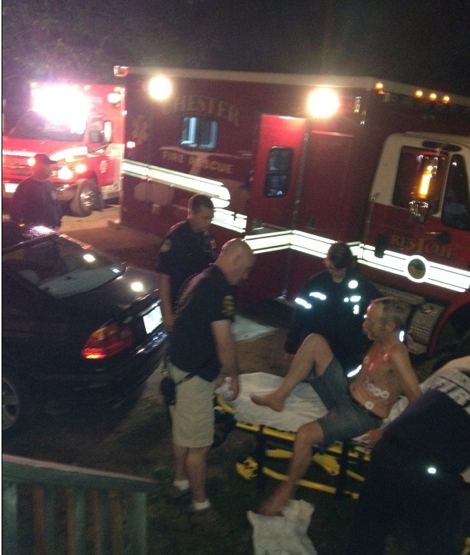

Nate left about 4pm and by 5pm I was cleaned up, drugged up, and martini in hand as I settled into my recliner to watch the Patriots season opener against the Titans on my Tivo DVR. I fired up Tivo only to find that for whatever reason it had recorded both the Pre-game and Post-game shows but not the game. A fitting end to my 51st Birthday Week from Hell. Can’t say I’m looking forward to my 52nd…..

TURNING 50 – September 2011

So I turned 50. Many of you celebrated with me at some point either during the backpacking trip deception or over a cocktail and/or cake over the last week or so or via e-mail and text messages - and I appreciate your thinking of me and taking the time to congratulate me via the many forms you chose.

My actual birthday was on Wednesday September 7. LOB doesn’t quit at 50, so I thought I’d share my day with you. My day started a couple of days earlier….

Late in the day on Labor Day, Monday September 5 I began to develop what I felt were “flu like” symptoms – headache, aching muscles all over, sweats and chills. By evening I’d also developed the sensation that I had to pee all the time, and this caused me to pee every 20-30 minutes. At the same time my sphincter muscle felt like I was clenching it, but I wasn’t. Rather strange. I got no sleep on Monday night as I was traveling back to the bathroom before I could fall asleep in each 20-30 minute window – reminiscent of my Bonds backpacking trip a few years ago (over hydration problem that time, not this time).

I got out of the sack Tuesday feeling sleep deprived and not well at all but this was to be yet another critical week on the project in CT so I felt I had no option but to travel. Tuesday was not a pleasant day at all. All the symptoms increased and I added a moderate cough which caused my head to feel like it would split open each time I coughed. My eyes ached and were watering, I was generally miserable and didn’t feel like eating and this probably added to my ailing situation. It was the first day since my employment at the electric company that I can remember watching the clock and feeling like the day was taking forever. I flew home leaving my laptop in its bag (another first) and tried to rest my eyes. I went directly from the garage to the shower and then to bed in the guestroom. No dinner, no martini, no checking my e-mail. Wow, I was obviously very ill based on those last two. I slept some on Tuesday night but still made many trips to the bathroom which now included a painful nearly burning sensation. Marvelous.

I got up on the 50th anniversary of my birth date feeling horrible but the project needed me and plus there was a huge milestone deliverable party tonight for the team which I’d put together at the Marriott. They deserved the celebration and I had a room and rental car reservation so I really need to go. My wife had told me during my very brief encounter with her the evening prior that I should stay home and get a doctor’s appointment, and I could do so online these days. The last time she’d really pushed on my skipping work and getting a doctor’s appointment I’d ended up overnight at the hospital getting morphine so I gave that some serious consideration and entered an appointment request online. When she woke I shared my overnight report and current condition with her and she told me to stay home and call Dartmouth-Hitchcock Clinic (DHC) at 7:00am when the admin staff arrived and follow up on my online request and get the answer to “who and when?” ASAP. She is very experienced with DHC and doctors office visits – an authority on the subject actually. After listening to her reasoning I decided that leaving for 2 days at that point probably wouldn’t improve my condition, I probably wouldn’t be very productive at work, I might share what I have with others, and I probably couldn’t enjoy the party anyway, so they’d have to celebrate on their own and I’d have to take care of myself. I did as instructed and received a 9:30am appointment with Mary Murphy, APRN in Internal Medicine at DHC.

I pee’d before I left and pee’d when I got there, 25 minutes in between. I checked in with main registration, then with internal medicine arrival, and by 9:30am was in my own exam room. Mary showed up at 10:00am (which fortunately had allowed me plenty of time to read a ratty edition of Interior Design) just as I’d reached my limit between pee trips. This did not faze her. Mary proceeded to ask me a thousand questions, half of which I’d already provided answers to either in my online appointment request or to other DHC personnel sitting in front of a computer and typing as they asked me these same questions. The other half of which she had in her computer but was ignoring. For instance “well you don’t have a temperature…” – but the PA who just took my vitals told me I did? “Oh, I missed that. OK” and “well you haven’t had a blood test in quite some time…” – I had one in February and again in July after the first one came back with high cholesterol and triglycerides information. “Oh, yes, now I see that…” and finally “well you’re 50 now we ought to check your PSA numbers….” – they were included in the February test and they were very good. “Oh, yes, they were…”. So I’m gaining tremendous confidence with Mary and all the while my need to pee is becoming urgent. So after I explained to her all of the symptoms I was having and when they started just as I’ve documented in the first couple paragraphs of this little tale and also pointed out for her all of the information in her computer which she couldn’t, Mary finally pulled all of her analysis together and summed it up for me with great confidence: “Hmmmm, you’re a bit of a conundrum”. ⬅ For real. She decided that I should provide 2 urine samples, one ‘dirty’ and another ‘clean’ (I’ll fill you in separately if you want more detail there) and I explained that since I was peeing frequently I did not have much volume and based on the process to provide these two specimens might not be able to accommodate. She told me to do my best but first she also wanted to perform a DRE. I explained that I’d had one during my annual physical in February and that Dr. Song hadn’t mentioned any abnormality during his little scouting effort there. She poked around in her computer but couldn’t find any notes with regard to that specific detail of the visit. Imagine that. She was adamant that based on my symptoms ‘we’ should do this. Great, a 2011 Two-Fer. When she began her own scouting effort I thought I was going to pee on her exam table. When she completed her exam she said “and now I need you to lie on your back so that I can examine your bladder and some other organs in that area”. No Mary, what you are going to do RIGHT NOW is give me those 2 specimen jars and get out of my way. “OK, we’ll finish the exam when you return”.

So the dirty specimen is subjected to a “dip stick” test while Mary completes her examination. The results of my visit to this point are:

- Urinary tract infection
- Slight fever – likely caused by infection
- Enlarged prostate – will receive referral to Manchester Urology

But Mary is not done and orders me to hit the Lab for blood work on my way out as she has a few other bases she needs to cover. Apparently that’s what they do when you are diagnosed as a ‘conundrum’. Mary writes me a couple of prescriptions – one for the infection and one to anesthetize the urinary tract so that I can get some sleep and hopefully spend less time in the bathroom.

I’m picking up my prescripts at RiteAid and the lovely young woman at the Pick Up window says “Last name and Date of Birth?” I provide the information and she says “Happy Birthday. Are you doing something fun for your birthday?” I spent the morning at the doctor’s office and now I’m here getting prescriptions. If that’s your idea of fun then I guess I’m having a blast. She maintained her smile and said “Well I hope it get’s better”. The world needs more of her. At any rate our little dialog gets me thinking that if I wanted to ignore my birthday and have it pass as simply another day then the last place I should have gone is the doctor. Everyone you deal with must confirm who you are and they do that by asking you for your last name and DOB. I counted back and determined that I was asked for my DOB 10 different times since getting up and it wasn’t even noon yet (online form, scheduler when I called at 7:30am, DHC Main registration, Internal Medicine Check-In, PA/vitals person, Mary/APRN, Internal Medicine Check Out, Blood Lab Check-In, phlebotomist, pharmacist.).

I went to work for the remainder of the day and on the way home decided to call Nate to share my doctor’s visit with him. Nate turned 50 two years ago and I spent his entire 50th year reminding him every week or so that he was 50 (he received 50 small gifts/reminders from me throughout the year). He’s been conjuring up the return favor since and he was already off to a good start but I knew this would make his day and if I couldn’t find humor in it myself then I was truly getting old. So I dialed him up and had him roaring in no time. At the end of the conversation he asked if he could stop by just very briefly that evening to drop something off. I wasn’t sure I should trust him based on the recent backpacking trip deception but he convinced me that it was safe.

Nate arrived about 5:45pm wearing a white smock, a backwards baseball cap, a surgeon’s mask and yes, blue latex gloves. God I’ve got good friends. His real interest in coming by was that when I’d called earlier he was holding a birthday card in his hands and was beginning to conjure up words to put to print for my turning 50 so my story was the perfect fuel for the card content. The card indeed elicited my laughter as well. To add to putting a smile on my face at the end of the day when I dug back into my e-mail and v-mail at work I found that my team had vetoed my decision and would not go out and celebrate without me, they would postpone it until I could join them. Terrific folks.

So there you have it, my 50th. Now many of you can understand how humorous your birthday notes have been to me with such well wishes as “I hope you do something memorable…”, “I hope you experience something that will last all year long…”, “It’s your day, make it special…”.

Here’s how I see it: “Welcome to 50. Make a doctor’s appointment”.

☺

BWO

